**Lab Test -01: Basic C#**

**Question Set: E**

**Web Programming using .Net**

**Time: 2 Hr. Score: 20**

**Make a simple book information keeper**

User will enter *ISBN* and *Name* in textbox and press *Add* button to add it in the ListBox below (as given in the figure). ISBN must be exact thirteen (13) characters long and unique. During add, this logic must be checked. User can add as many book information as (s)he wants.

In search part, user will select either *ISBN* or *Name,* enter text and press *Search* button, that specific book’s name will be displayed in the ListBox below.

**Hint:** Key value pair.

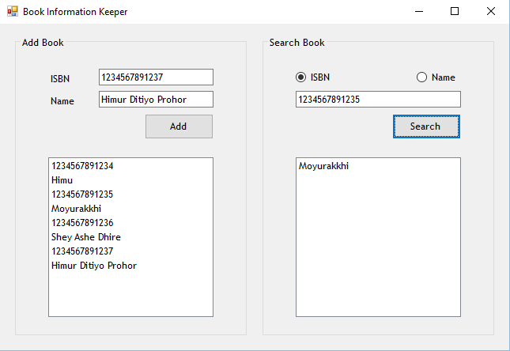

**Judgment criteria of this lab test:** Functional, Naming convention, Code quality, Indentation, UI layout.